

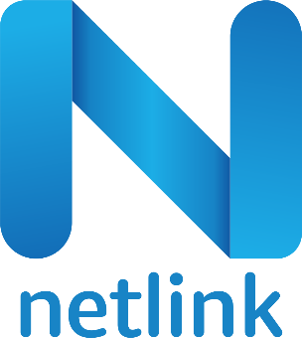

Netlink Software Canada Inc.

**Response to AJMAN CHAMBER RPA RFP**

**Technical Proposal**

21 Aug 2022

**Submitted To:**

**AJMAN CHAMBER**

Netlink Software Group America Inc.

Global HQ - 999 Tech Row, Suite 100, Madison Heights, MI 48071| M: +1-1800-485-4462

[*www.netlink.com*](http://www.netlink.com/)

**Table of Contents**

1. COVER LETTER/EXECUTIVE SUMMARY 2
2. NETLINK PROFILE 4
3. PROJECT GOVERNANCE 7
4. PROJECT IMPLEMENTATION APPROACH 7

Proposed Architecture 8

1. SCOPE OF WORK 9
2. DELIVERY METHODOLOGY & APPROACH 10
3. PROJECT PHASES AND TEAM ENGAGEMENT 11

Analysis 12

Design 12

Development 13

System Integration testing 13

User Acceptance Testing 14

Warranty 14

Project Team 15

1. SUPPORT 15

Hours of Operation 15

Average and Guaranteed Response Time 15

1. TRAINING PROCESS 16

Guiding Training Philosophy 16

Identification of Client Training Gaps/Needs 16

Forms/Methods of Training Utilized 17

Availability of Trainers / Training Material 17

Updates to Training Materials 17

# Cover Letter/Executive Summary

Aug 21, 2022

Ajman Chamber

Subject: Response to Request for Proposal for Robotic Process Automation

Dear Mr. Mahesh,

Netlink appreciates the opportunity to bid for the Ajman Chamber Robotic Process Automation RFP. Netlink has proven track record in implementing IT projects and providing IT services including ERP for global enterprise clients including Fortune companies. Our enterprise application services cover a range of industry leading ERP software, RPA Software, Low Code Platforms, BI & Analytics and many more. Hence, Netlink is in an excellent position to fulfil the requirements specified in this RFP.

Netlink is a MMSDC certified company based at Madison Heights in the State of Michigan in the Detroit region with our Delivery Centres in India, Dubai, Canada and Australia. Our strong presence in Middle East would be a significant advantage for this contract. Founded in 1999, Netlink is a premier provider of information technology, business analytics, application management and business process solutions. The core business philosophy of Netlink is to deliver Immediate Business Results to our customers. Apart from MMSDC certification, Netlink has the following partnerships and certifications:



Netlink is committed to corporate social responsibility (CSR) initiatives and has joined hands with 11+ Charities via “Netlink Foundation” - Corporate Citizenship arm of Netlink. Netlink Foundation is 501(c)(3) created to support children's rights and create sustainable change in the communities it serves since 2008. We believe that children are the future and strive to create sustainable change in

their world through this entity. Netlink Foundation assists with funding for food, medical care, education, housing, and clothing; Works to show children the potential of their future through access to universities, other children's charities, and support systems.

Netlink has submitted the RFP response/proposal document via Email. In addition, the following attachments have been submitted:

* Technical Proposal
* Commercial Proposal

This proposal is firm for a period of 45 days from the proposal due date and thereafter until the prospective vendor withdraws it, or the procurement is terminated by Ajman Chamber.

Sincerely, Kranti Batchala

Associate Vice President – Enterprise Solutions [kkbatchala@netlink.com](mailto:kkbatchala@netlink.com)

Telephone: +91-9589277912 (Cell)

# Netlink Profile

Founded in 1999, Netlink is one of the leading providers of Application Management, Infrastructure Management, IT assessment, Business Analytics and Business Process Outsourcing solutions and services.

Netlink built IoT technologies to help automate manual processes across any enterprise. Monitoring, collecting, and exchanging data provides insights to enhance the work of your employees. Interaction with websites, desktop applications, databases, and people executes the repetitive and mundane data collection work while lowering operational costs.

Netlink provides enterprise-grade AI and Machine Learning Solutions to help organizations to generate insights and to make the best use of massive and fast-moving data. We build and deploying scalable solutions combined with superior research work, use case-specific, and industry domain expertise.

* + 22+ Years of IT experience
  + 2000+ Team members worldwide
  + 10+ Locations worldwide
  + 100+ Successfully delivered projects
  + 11+ Charities
  + 20+ Innovation awards & Recognitions

#### Awards, Recognition and Community Associations

* + 2014 Crain’s FAST 50: Fastest-growing Companies #12.
  + Silicon India si100 2014 Vote of Respect from Industry Leaders.
  + Multiple Client Awards: Lear Supplier of the Year, Beechcraft Strategic Supplier, Ford Strategic Supplier, Sirius XM Supplier Innovation.
  + Inc. 500, E & Y Entrepreneur of the Year.
  + Fastest Growing Private Companies – Crain's Business (multiple years), NPR – National Radio Coverage, Technology Company of the Year – Automation Alley.
  + Best IT Company in Michigan — Corp! Magazine.
  + 2015 Emerald Sponsor of Michigan Council of Women in Technology.
  + Michigan Governor’s Recognition Award.
  + Official Technology Partner and Sponsors of Music Hall Detroit, Toronto International Bowl, Motor City Bowl.
  + Community Service – Netlink Foundation: UNICEF Child Rights Observatory, United Way, VIP Mentoring, Inner City Public Schools.
  + Partnered with multiple charities for underprivileged children’s “Possibilities” initiative in Detroit and Flint, MI.

#### Industries Served by Netlink

As global providers of technology-based solutions, Netlink offers an array of services including Application value management, BI and Analytics, Document image management, Data center and Hosting services, Back-office services, consulting and e-learning solutions to its clients.Industry sectors served by Netlink include:

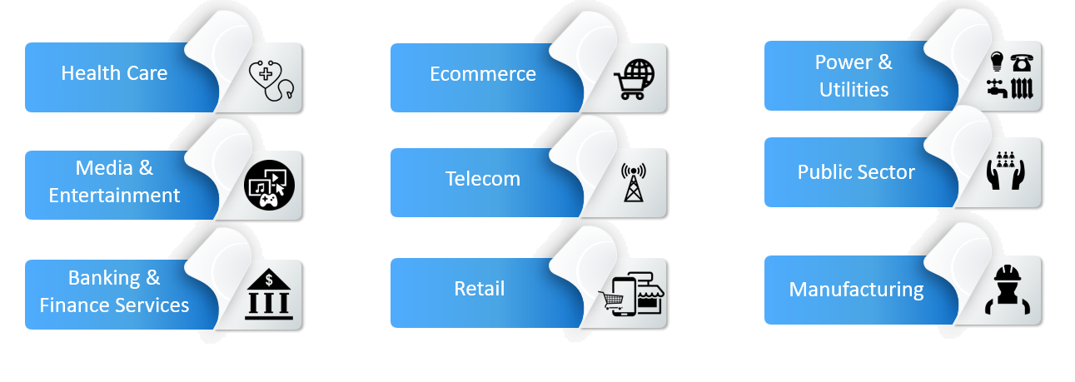

### Selected Netlink Customers

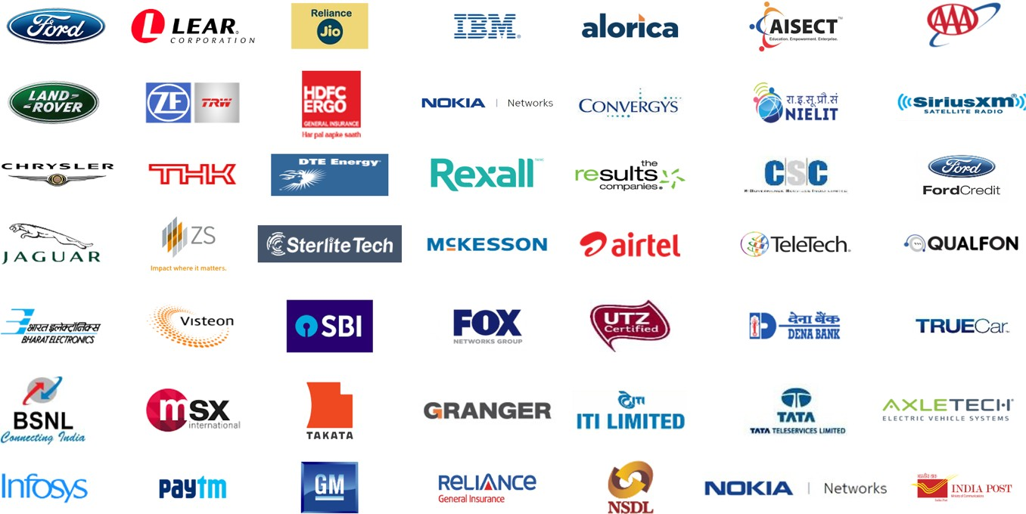

#### Lumenore, A Netlink Product

Lumenore, a Netlink product is a modern augmented analytics platform which utilizes a common dataset to feed its powerful platform to visualize, analyze, actionize, as well as monetize business operations.

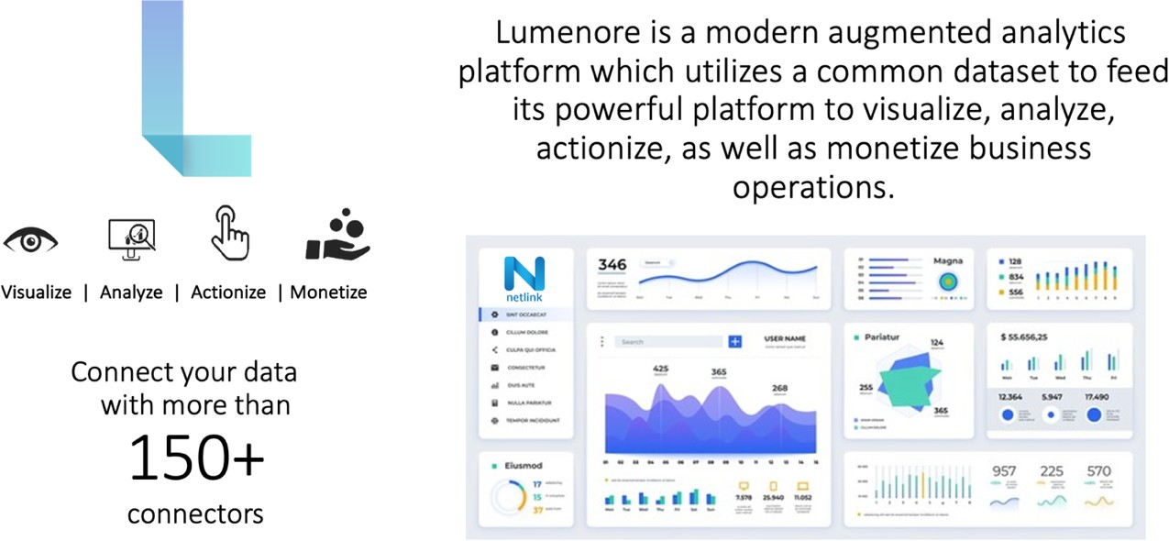

# Project Governance

Netlink will follow the below Governance Model throughout the multiple phases of this project:

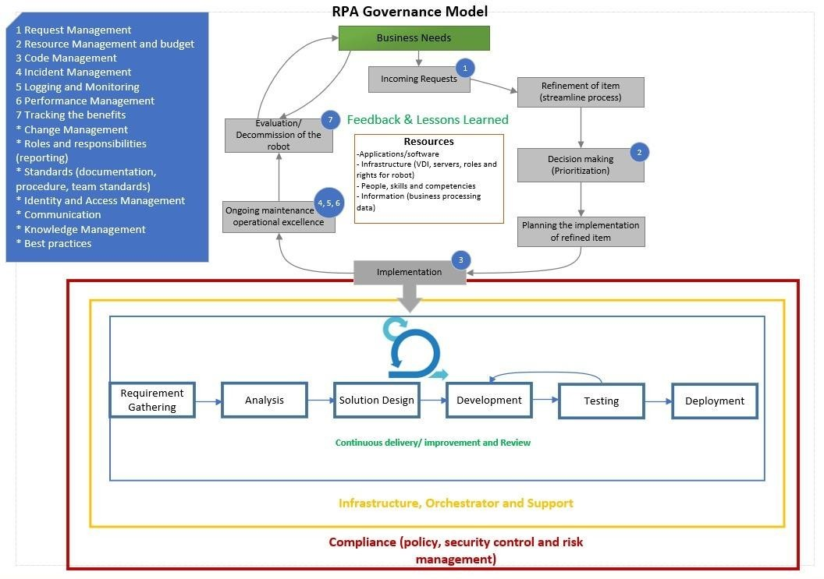

# Details of any tools and/or accelerators that will be used

Netlink proposes to use UiPath Technology stack to deliver this automation project. Below are the various UiPath components that are required to be licensed for smoother delivery of this project.



UiPath Studio allows RPA developers to create workflows, with API integrations to an ever-growing list of applications, technologies, and platforms. More complex automations are easily handled with basic coding knowledge.

Users: RPA Developer, Business Decision Maker, Business User



Orchestrator Deploys, manages and optimizes your Robots with enterprise-scale integrations and compliance.

Users: RPA Developer, IT Admin, CoE Admin



Run automations with software robots that are intelligent, flexible, and eager to take on tedious tasks. Users: CoE Lead, Business Decision Maker, Technical Decision Maker, RPA Developer, Automation User



Lets all the users interact with robots right on their desktops through an easy-to-use launchpad. Users: Automation User



Uses AI-enhanced skills to extract data and interpret documents. It can process different document types and formats, including tables, handwriting, signatures, and checkboxes. Uses human validation to confirm extracted data if needed, handle exceptions, and train models to improve their accuracy over time.

Users: RPA Developers, Business Process Owners, CoE members, CIOs

## 

## Proposed Architecture

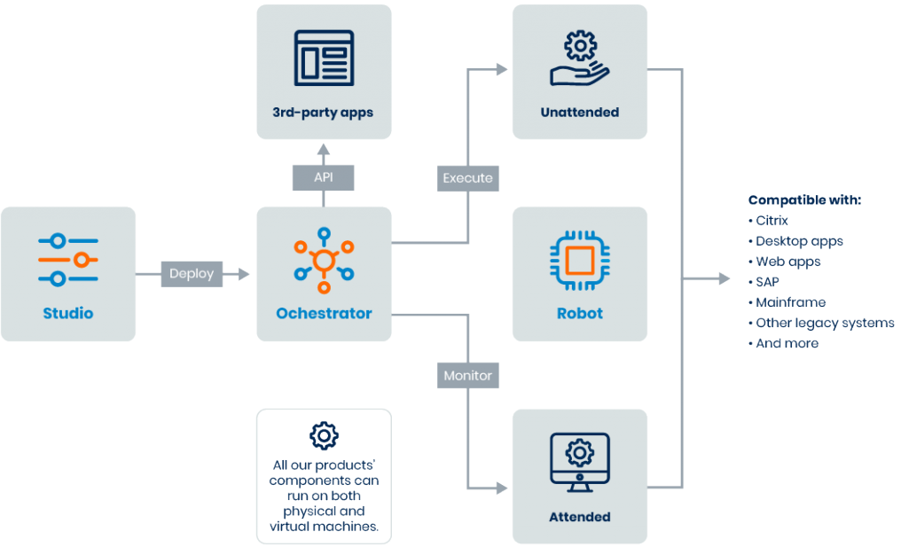

To make the integration with Ajman Chamber systems seamless, we propose the usage of Orchestrator for not only scheduling the robots but also to use it as an integration platform.

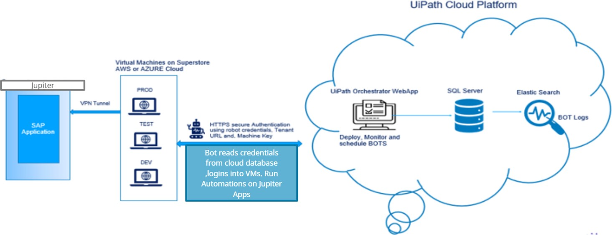

# Scope of Work

Netlink understood the Ajman Chamber IT landscape discussed in the meeting and concluded the scope of work as below:

* + UnAttended Bot development addressing all the requirements of the project in scope
  + Completion of the project, with the details of the project being implemented for the respective scenarios
  + Source Code handover
  + Execution Log Report as Output file
  + Knowledge Transfer on the completed process
  + Report contains the metrics of the duration of BOT execution time.
  + Number of tasks completed by a BOT.
  + BOT pass / failed status.
  + Complete report on BOT on daily basis.

Below are the in scope processes for automation.

* + Certificate of Origin Verification
  + Signature Verification
  + Certificate of Origin Creation

# Delivery Methodology & Approach

Netlink will use a hybrid development methodology using Waterfall during Requirements gathering phase and Agile in design and development phases.

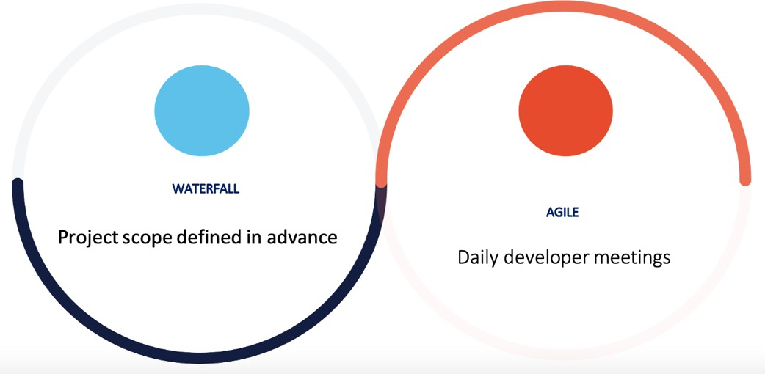

#### Development Approach:

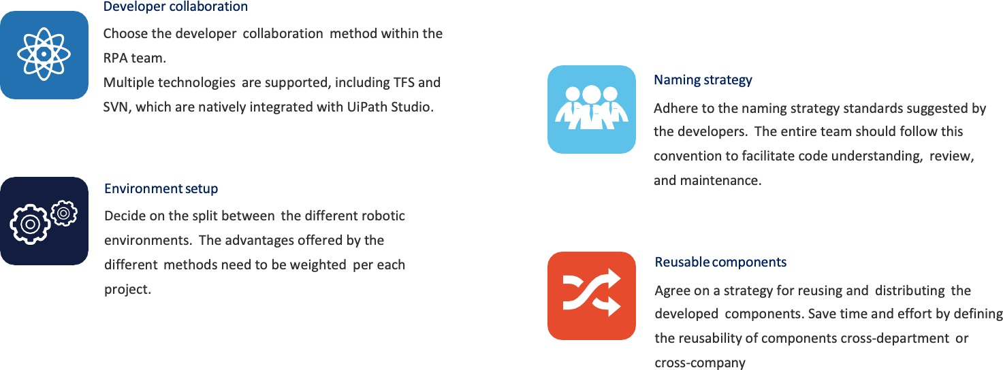

**Project Roles**

* + Technical Solution Architect
  + RPA Developer Business Analyst
  + Analyst
  + Process Owner
  + RPA Developer
  + SME

# Project Phases and Team Engagement

This section talks about the different project phases and the team engagement based on each project phase.

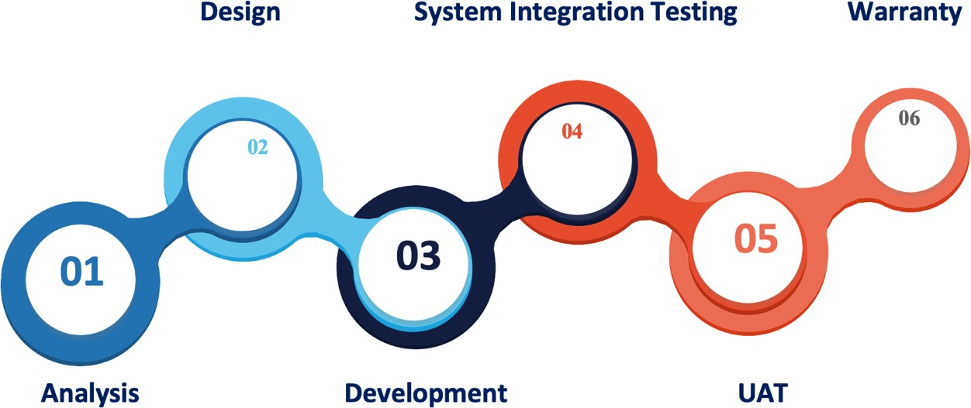

## Analysis

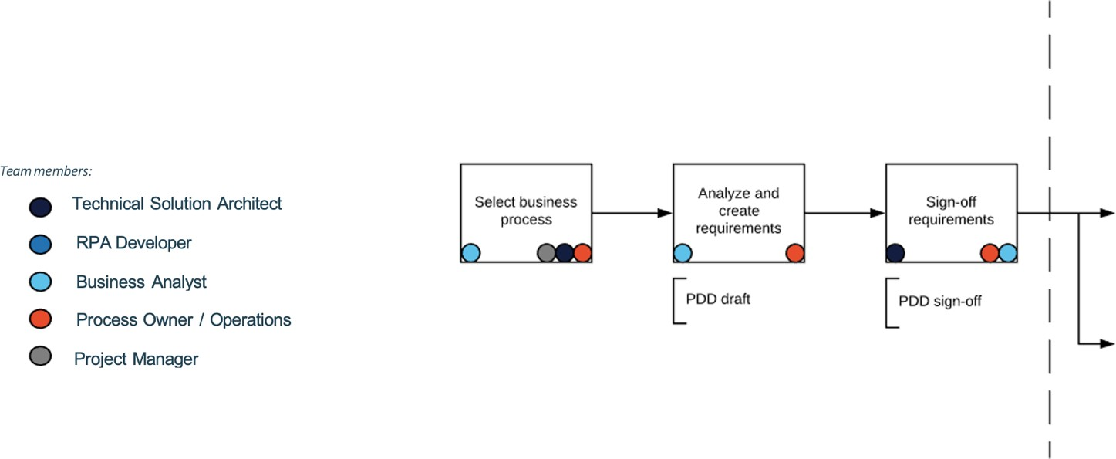

## Design

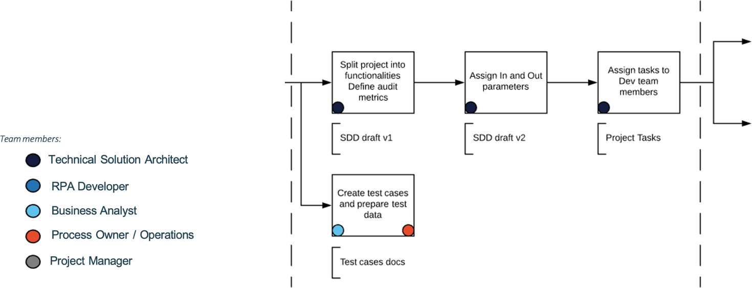

## Development

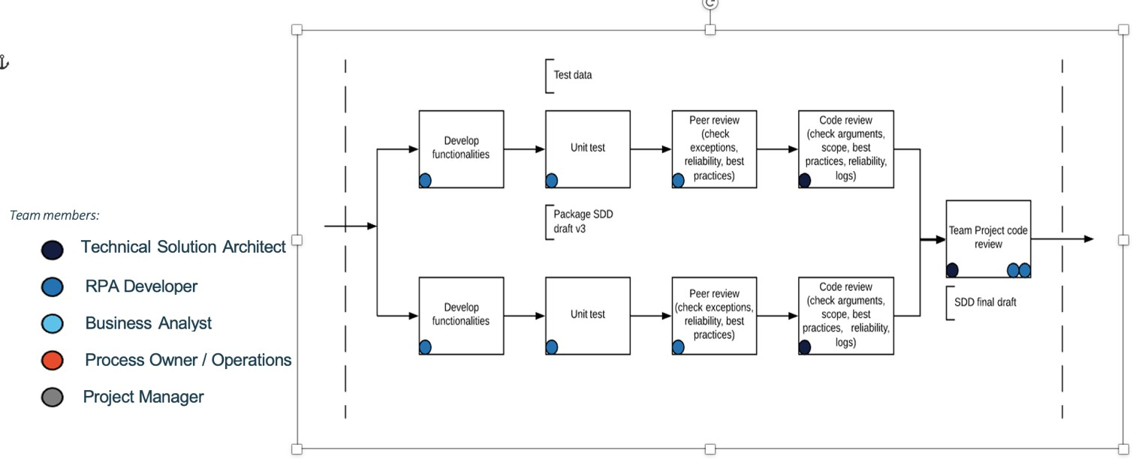

## System Integration testing

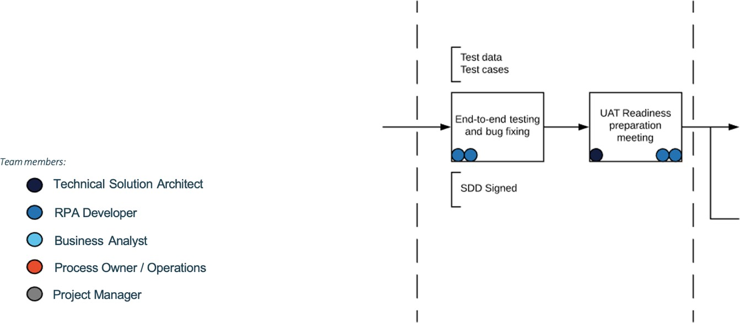

## User Acceptance Testing

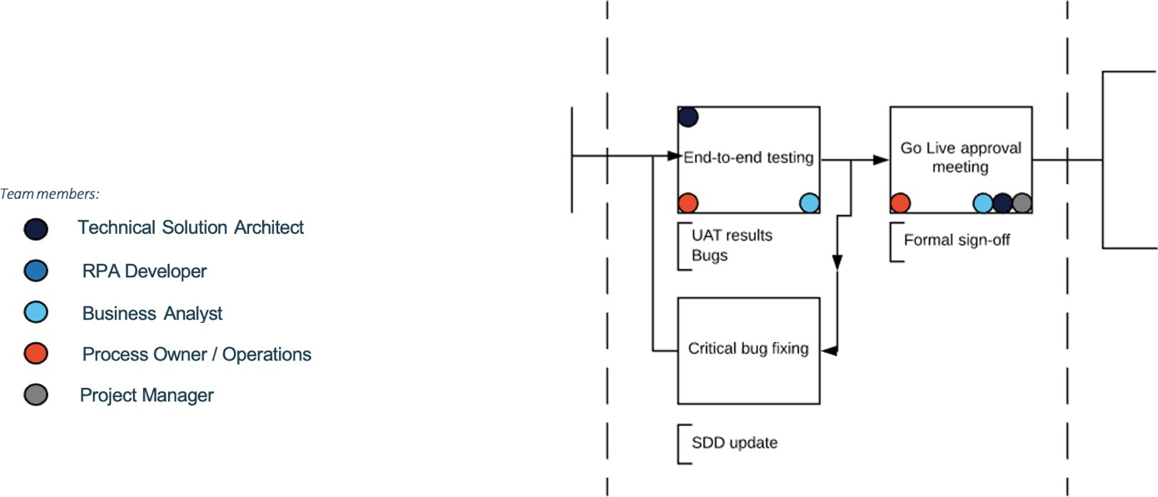

## Warranty

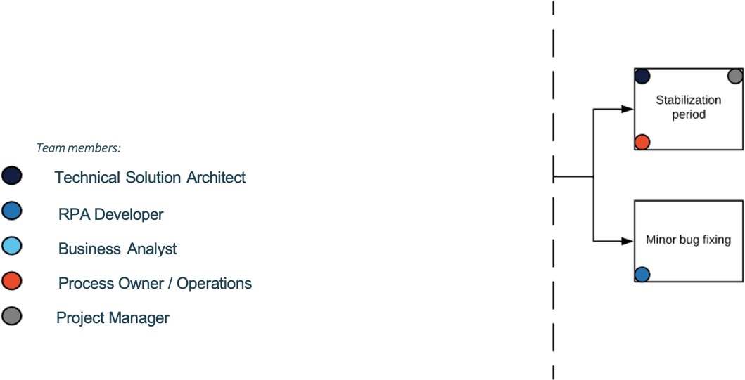

**Use Case 1 - Certificate Of Origin Process Workflow**

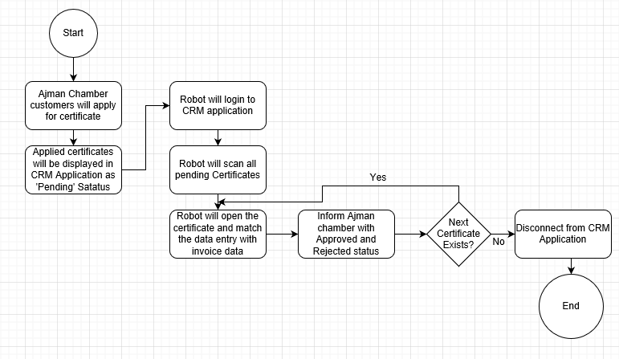

**DETAILED PROCESS FLOW**

Step 1- Robot will login to CRM application with valid user credentials.

Step 2- Robot will click on certificate of origin tab.

Step 3- Screen displays different certificates applied by different customers.

Step 4- Robot sort the certificate of origin by pending status.

Step 5- Robot will process all pending certificate one by one and follow the below steps:

1. Robot will open the certificate by using the unique certificate number.

2. Inside the certificate we have attached invoice and data entered by user.

3. Robot will open the invoice and match the information with the entered data like:

Member Company

Consignee

Destination Country

Invoice Value

Product details

Step 6- After validation robot will send the text file with Approved or Reject status

If the information match robot will send the certificate number with Approved Status to Ajman Chamber.

If the information match robot will send the certificate number with Rejected Status to Ajman Chamber.

**Process Success Output**--

For the Certificate of Origin Use case, Robot will validate the data entry and send the text file with Approved or Rejected Status to Ajman Chamber for all Pending Certificates.

**Process Complexity --**

1. Language translation from Arabic to English.

2. Different Invoice Format.

## Efforts Estimation for RPA – Certificate of Origin:

|  |  |
| --- | --- |
| **Tasks** | **Client Name- Finance Voucher Automation (Hours)** |
|
| Requirements Gathering | 15 |
| Design/Creation of Solution design document | 15 |
| Development | 350 |
| Testing | 120 |
| UAT & Production deployment | 20 |
| Hyper care/Support | 24 |
| **Total** | **544** |
| **Total Efforts** | **14 Weeks** |

**Project Schedule / Timelines**

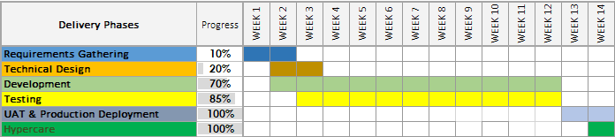

**Use Case 2- Signature Verification Process Workflow**

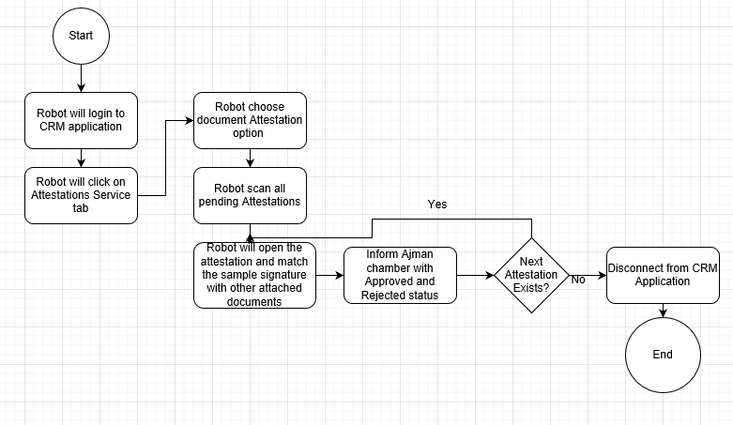

**DETAILED PROCESS FLOW**

Step 1- Robot will login to CRM application with valid user credentials.

Step 2- Robot will click on Attestations tab and choose Document attestation option.

Step 3- Screen displays different attestations applied by different customers.

Step 4- Robot sort the attestations by pending status.

Step 5- Robot will process all pending attestation one by one and follow the below steps:

1. Robot will open the attestation by using the unique attestation number.

2. Inside the attestation we have attached documents with sample signature attachment.

3. Robot will open the signature attachment and read the signature.

4. Robot will verify the signature in all attached document with the original signature provided by user

Step 6- After verification robot will send the text file with Approved or Reject status

If the signature match robot will send the certificate number with Approved Status to Ajman Chamber.

If the signature does not match robot will send the certificate number with Rejected Status to Ajman Chamber.

**Process Success Output**--

For the Signature Verification Use case, Robot will verify the Signatures and send the text file with Approved or Rejected Status to Ajman Chamber for all Attestations.

**Process Complexity --**

 1. Attachment can be in both English and Arabic.

2. Different Invoice Format.

3. Signature Verification

## Efforts Estimation for RPA – Signature Verification:

|  |  |
| --- | --- |
| **Tasks** | **Client Name- Salvage Automation (Hours)** |
|
| Requirements Gathering | 12 |
| Design/Creation of Solution design document | 12 |
| Development | 250 |
| Testing | 80 |
| UAT & Production deployment | 12 |
| Hyper care/Support | 24 |
| **Total** | **390** |
| **Total Efforts** | **10 Weeks** |

**Project Schedule / Timelines**

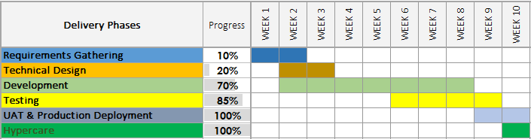

**Use Case 3 -Creation of Certificate Process Workflow**

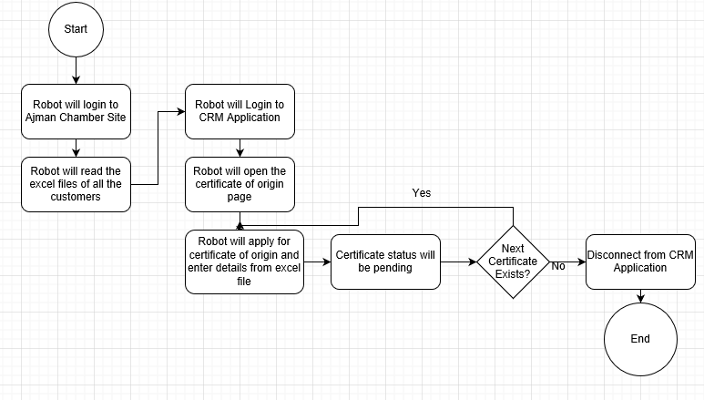

**DETAILED PROCESS FLOW**

Step 1- Robot will login to Ajman chamber site with valid credentials.

Step 2- Robot will read data from excel file.

Step 3- Robot will login to CRM application with valid user credentials.

Step 4- Robot will click on certificate of origin tab and apply for certificate.

Step 5-Robot create certificate and enter data from excel file.

Step 6-Status of Certificate will be Pending status.

Step 7- Robot will create different certificate one by one for the same customer present in Excel.

**Process Success Output**--

 For the Creation of Certificate of Origin Use case, Robot will read excel file from ajman chamber site and create certificate of origin in CRM application.

**Process Complexity --**

1. Data can be in both English and Arabic Language.

## Efforts Estimation for RPA – Creation of Certificate:

|  |  |
| --- | --- |
| **Tasks** | **Client Name- Recovery Automation (Hours)** |
|
| Requirements Gathering | 20 |
| Design/Creation of Solution design document | 20 |
| Development | 280 |
| Testing | 120 |
| UAT & Production deployment | 24 |
| Hyper care/Support | 24 |
| **Total** | **488** |
| **Total Efforts** | **12 Weeks** |

**Project Schedule / Timelines**

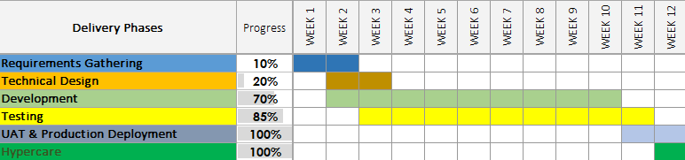

**Criteria for considering the development done for a process**

1. Code produced (completed all ‘ToDo’ items in code)

2. Code commented according to best practices, checked and ran against current version in source control

3. Peer reviewed (or produced with pair programming) and meeting development standards

4. Passed unit tests

5. Deployed to system test environment

6. Passed System Integration tests and signed off as meeting requirements

7. SDD document filled in and approved

8. Relevant documentation/diagrams produced and/or updated

# 

# 8. Support

This section describes in detail the support process that would be adopted by Netlink for fulfilling the in-scope requirements. The details requested in the RFP have been provided in the following paragraphs.

## Hours of Operation

Unless called out otherwise, Netlink will provide the requisite support to meet Client’s requirements during the business hours specified below:

* + Regular Support: Monday to Friday, 8 a.m. to 5 p.m. Local Time, excluding holidays
  + Emergency Support: 24 x 7 x 365
  + 24 x 7 Service Desk to receive and route Client’s L2 support needs via:
    - E-mail
    - Phone
    - Self-service portal

## Average and Guaranteed Response Time

Netlink’s issue/ incident classification model ensures timely response to service requests. This model is based on the following evaluation criteria:

|  |  |
| --- | --- |
| **Criteria** | **Severity Level** |
| **Critical –** The IT function affected is unavailable and is required for the  primary business operations of Client or its end-customers | Severity 1 |
| **Serious –** The IT function affected is not fully available and is required for the  business operations of Client or its end-customers | Severity 2 |
| **Other –** The IT function affected does not impact business operations, but is  included in the scope of services provided by Netlink | Severity 3 |

|  |  |
| --- | --- |
| **Prioritization Criteria for Request** | **Priority Code** |
| Funded by Client’s end-customers or Change requested by business critical  Functions | Priority 1 |
| Potential for additional business (Client initiated)  Business unit committed to pay for change that is customer facing | Priority 2 |
| All other scenarios | Priority 3 |

# Training Process

This section describes in detail Netlink’s training process.

## Guiding Training Philosophy

* Train the Trainer approach is included for training.
* Train the Trainer scope will be limited to Oracle Fusion to deliver the in-scope functionality to Client.
* Netlink will provide the required knowledge and process expertise to Client by means of “Train the Trainer” approach conducted by the respective Functional Leads.

## Identification of Client Training Gaps/Needs

Netlink will start to identify the training gaps / needs right from the project kick-off stage by:

* Reviewing existing training documents and processes
* Conducting key business user interviews to identify deviation from standard operating procedures
* Auditing recent ticket history to identify areas for training needs

## Forms/Methods of Training Utilized

* Workshops
* Virtual / Webinars
* Audio / Video/ Organizational Process Assets & Training Material

## Availability of Trainers / Training Material

* Trainers will be available as per the schedule that Netlink and Ajman Chamber agree to.
* A training calendar will be published periodically as per the identified training needs.
* Netlink proposes a dedicated space for Organizational Process Assets where the knowledge base will be stored with documents like:
  + Graphical Business Process Procedures and job aids
  + Business scenarios as applicable to current existing process used at Ajman Chamber along with working instructions

## Updates to Training Materials

Training materials will be updated by the respective trainers/ functional experts in the following scenarios:

* Any new change implementation
* Any issue identified in current process is resolved
* Any process